BUTLEY, WANTISDEN & CAPEL ST ANDREW PARISH COUNCIL | 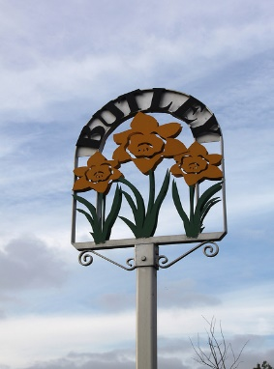
Chairman: Cllr David McGinity
Parish Clerk: Joanne Peters, Neutral Farm House, Mill Lane, Butley. IP12 3PA
Tel: 01394 459400, E-Mail: butleyparishclerk@gmail.com

Notice is hereby given that the ANNUAL PARISH MEETING
will be held virtually on Thursday 29th April 2021 at 7:30pm
via Zoom

Members of the public are welcome to attend. Please contact Jo Peters,
Parish Clerk for the meeting link

AGENDA

Welcome by The Chairman and to open the meeting

- To receive apologies for absence

- To approve the minutes of the Annual Parish Meeting held on 9th May 2019

3. To receive reports from:
Suffolk County Councillor Andrew Reid
East Suffolk District Councillor James Mallinder
Councillor David McGinity (Chairman of the Parish Council)
Butley Village Hall Management Committee
Butley PCC
Butley W.I
Butley Oyster Inn

4. Items specific to Butley

5. Items specific to Capel St Andrew

6. Items specific to Wantisden

7. Public Forum

Signed: David McGinity, Chairman Dated: 16th April 2021

